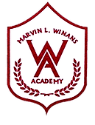

WINANS ACADEMY OF PERFORMING ARTS
GOOGLE CLASSROOM STUDENT GUIDE
G suite Education

Please follow the instructions below to sign in to Google Classroom.
- Open Google Chrome and navigate to the following URL in your web browser: https://classroom.google.com
- Sign in to your classroom portal using the email address provided by your teacher or school
- Next, select your role: Pick your role > I’m a Student
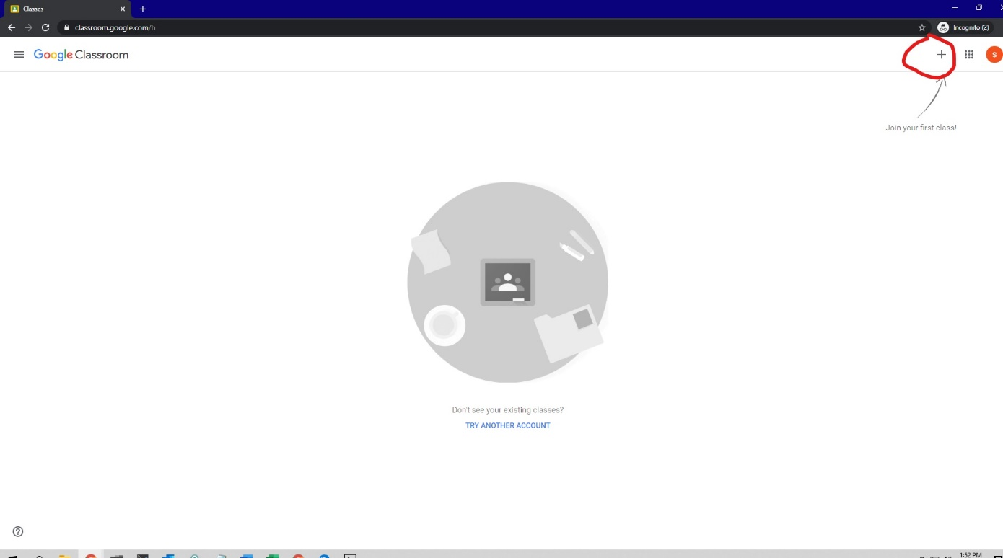
- Select “+” located in the upper right corner of the webpage - see example below

- Enter the class code provided by your teacher or school. You will need to do this for each class you are enrolled in
