DELL Chromebook student login procedure

Power on the device.
On the signin screen you will enter the students username and password in the following format:
Username: Firstname.Lastname (do not include @winans.spfs.k12.mi.us, it is added automatically)
Password: wapastudent
Open the Google Chrome web browser
Select Log in with Google as shown below
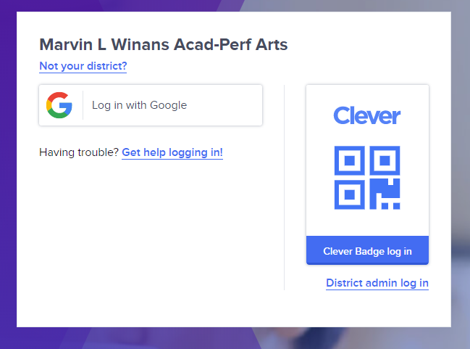

You will be redirected into your Clever portal that will contain all of your learning applications
Dell Latitude 3470/3570

Power on the device.
Sign in with the following username and password :
Username: wapa12
Password: saw
Open the Google Chrome web browser and create a new profile as shown below.

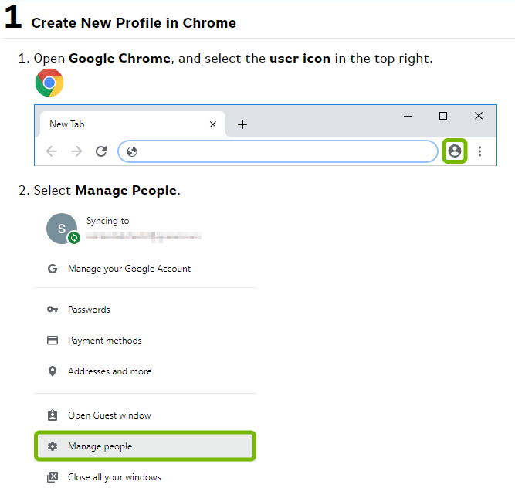

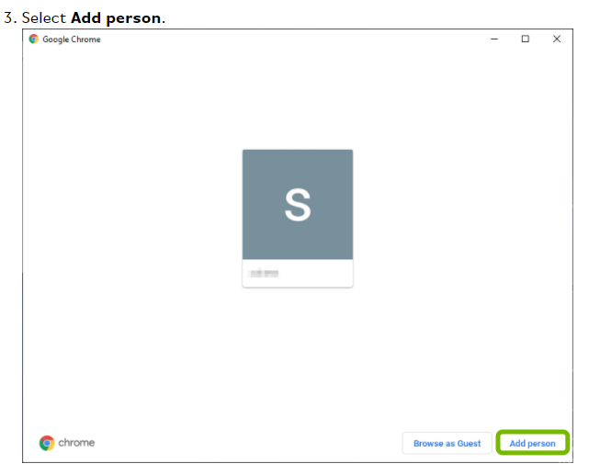

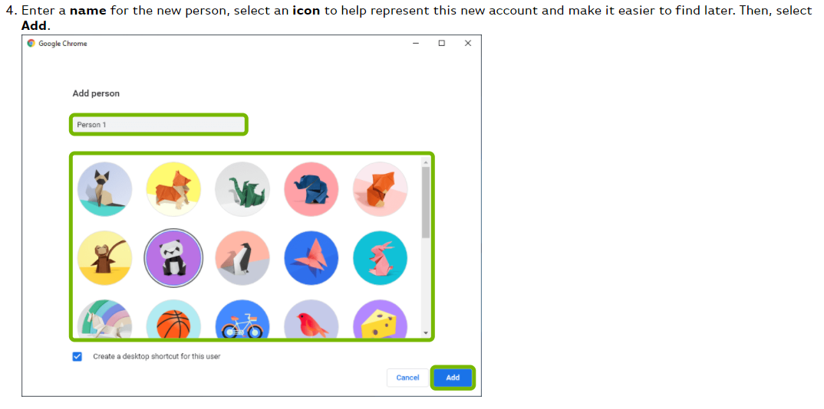

5) Select Sign in (see the red arrow below) and enter the students username as follows
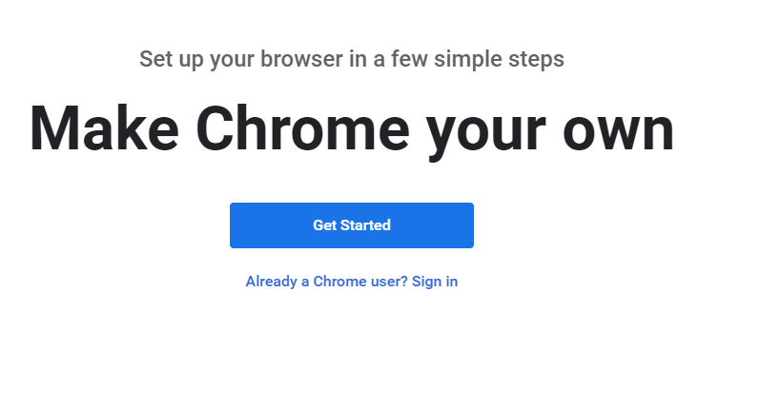

Continue to next page…

Enter username in the Email or phone box show below
Username: Firstname.lastname@winans.spfs.k12.mi.us
Password: wapastudent
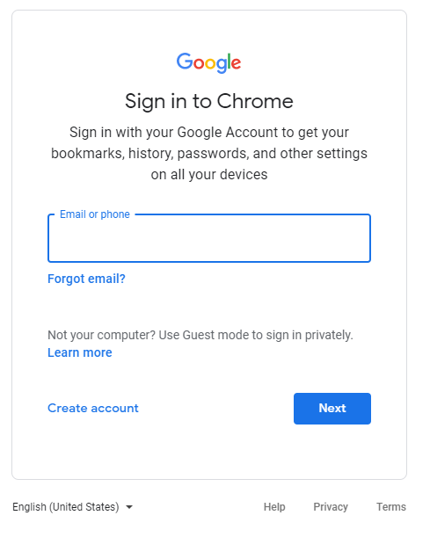

*Note: All students have a Google Education username (email address) that must be specified when creating a Google Chrome profile. Do not use any account ending in @gmail.com –See next page for example
Firstname.lastname@gmail.com
Fristname.lastname@winans.spfs.k12.mi.us

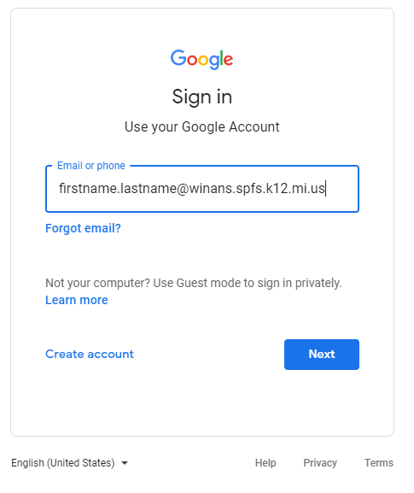

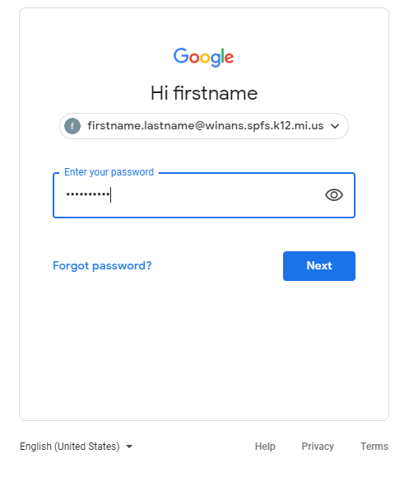

Enter your password and accept the end-user license agreement (EULA)

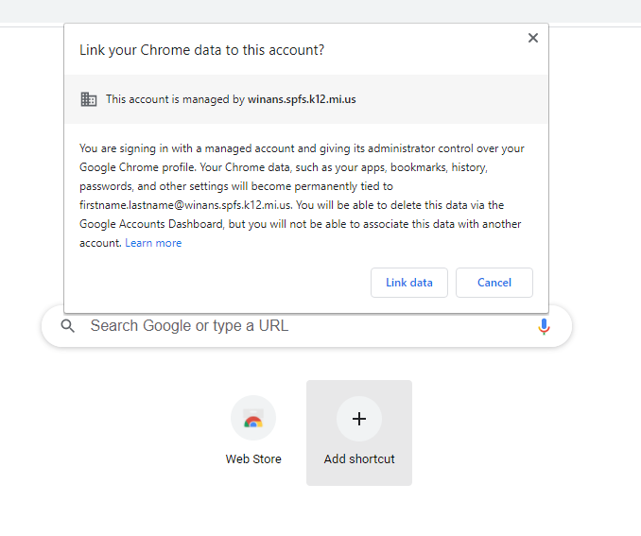
Now select Link data

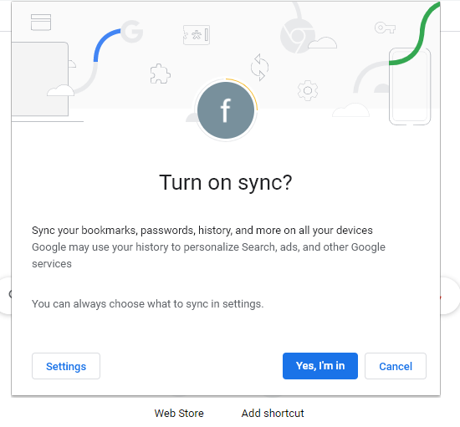

Select Yes, I’m in

Close down or exit the Google Chrome web browser by clicking the “X” in the upper right corner.

Close down or exit the Google Chrome web browser by clicking the “X” in the upper right corner.
Re-open Google Chrome and you will see the following

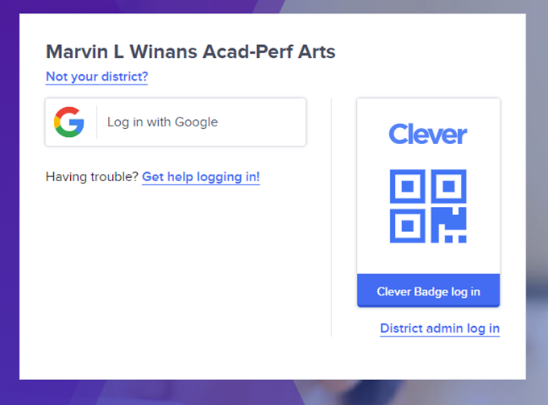

Select Log in with Google and you will be redirected to your Clever portal.

Kindle Fire HD (Tablet)

Open the Silk browser (see the image below for the location of app)
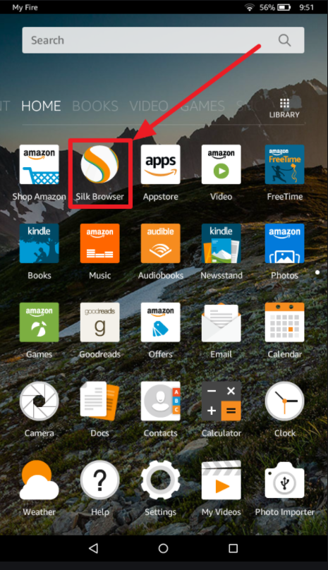

Navigate to the following URL https://clever.com/in/wapa
Select Log in with Google
Enter student username as follows
Username: Firstname.Lastname
Password: wapastudent
You will be redirected into your Clever portal that will contain all of your learning applications.

